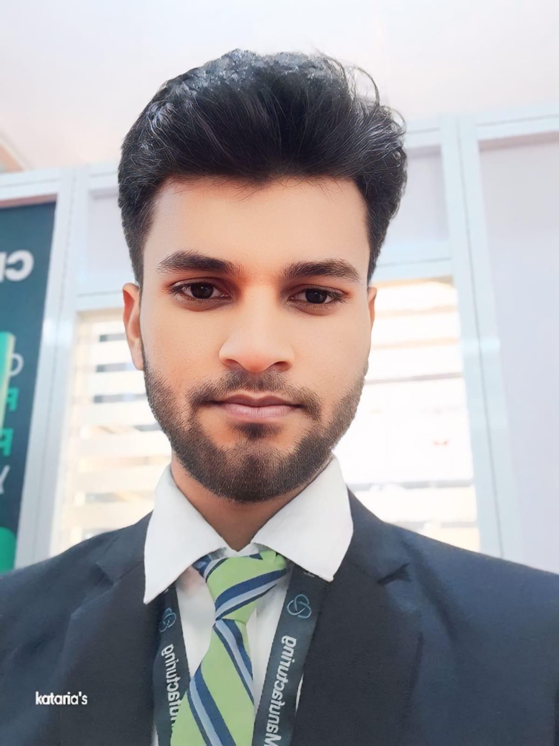
Umang Kumar
Greater Noida | umangkumarravi123@gmail.com | +91 9258405605 | Linkedin | Github | Portfolio
Professional Summary

Detail-oriented Computer Science student skilled in Java and web development using HTML, CSS, JavaScript, React, and Node.js. Passionate about leveraging problem-solving skills, exploring emerging technologies, and building efficient, scalable, and user-focused software solutions.

Education
Galgotias University, B.Tech in Computer Science and Engineering (CGPA:8/10) August 2022 – May 2026
- Coursework: DSA, SDLC, Databases Management System, Object-Oriented Programming System.
MDS Inter College, XIIth (Percentage: 75%) April 2021 – June 2022
ARN Kela Inter College, Xth (Percentage: 81%) April 2019 – May 2020

Skills
- Languages : Java(proficient), JavaScript, SQL, C# (Basics),Python (basic) .
- Frontend Technologies and Frameworks : React.js, Next.js, JavaScript, CSS3, Taiwind CSS, Bootsrap, HTML5.
- Backend DataBases :Node.js, Express.js, REST API, WebSockets, MySQL, MongoDB.
- Tools DevOps :Git, GitHub, Netlify, Railway, VS Code, Vercel, Render.

Projects
Blog(Blogify) Repository Link Live Link
- Implemented secure user authentication for over 2 user roles (Admin User) using JWT and Express middleware, reducing unauthorized access by 100
- Integrated Multer for image upload, supporting media-rich blogs and improving user engagement by 35%.
- Used MongoDB for dynamic data storage, handling over 500+ blog entries during testing without performance degradation.
- Secured user credentials by implementing bcrypt-based password hashing with salting, protecting against plaintext leaks and enhancing authentication security by 90%.
ImageCompressor Repository Link Live Link
- Developed a client-side image compression web app using React.js and the HTML5 Canvas API, enabling users to upload and compress images directly in the browser.
- Implemented real-time image resizing and quality reduction with an intuitive UI for original vs. compressed image comparison
- Deployed the project on Netlify for global accessibility and optimized performance.
- Enhanced overall app efficiency by achieving up to 80%.
Medical Imaging Diagnosis Portal Repository Link Live Link
- Developed a full-stack Medical Imaging Diagnosis Portal enabling users to upload reports (PDF/images) and receive AI-based analysis in real time.
- Implemented CNN-based and rule-based AI processing to detect abnormal medical values and generate preliminary diagnosis with severity levels.
- Built a responsive frontend using React.js and Tailwind CSS and integrated backend using Node.js, Express, and MongoDB.
- Integrated OCR and report parsing to extract data from medical images and provided actionable insights like precautions, diet, and recommended tests.

Acheivement and Certificates
Certificates:
Java Full Stack - (Wipro) LinkedIn
java Course completion - Programming Hub LinkedIn
LeetCode Profile LeetCode
GFG Profile GFG

